P A G E | 1

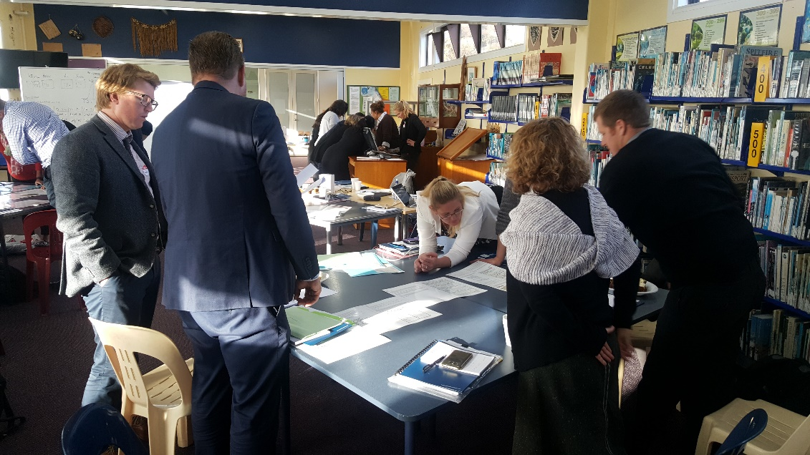 | Central  Catholic Community of Learning  BOT  Information Flyer 4

WORKING TOGETHER FOR ALL OUR CHILDREN

Waiho I te toipoto Kaua I te toirua
Let us keep close together, not far apart
Term 2 2017
Schools in the Community
- St Mary's College (Ponsonby)
- St Paul's College (Ponsonby)
- St Peter's College (Epsom)
- Marist College
- Christ the King Catholic School (Owairaka)
- Good Shepherd School
(Balmoral)
- Marist School (Mt Albert)
- Marist School (Herne Bay)
- Monte Cecilia Catholic
School (Mt Roskill)
- St Dominic’s Catholic Primary School (Blockhouse Bay)
- St Therese School (Three Kings)

What are the up-dates?

1. 2 new appointments of Across the School Teachers AST
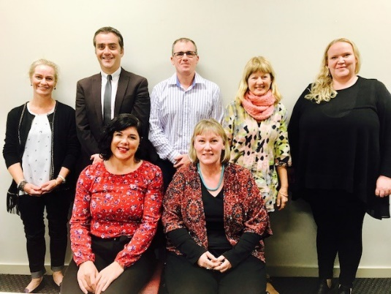
Our team of Across the School teachers
Melissa Down
Good Shepherd Catholic Primary School

Being selected as an Across School Teacher for the ACC Kahui Ako is a great privilege and I am looking forward to the learning opportunities it will provide. I am currently a year 5 and 6 teacher at Good Shepherd School and a member of the Senior Leadership Team. Prior to taking up the role as an AST I was also the DRS. I have a number of passions including visual art, math, literacy and engaging reluctant learners.
Education is not preparation for life; education is life itself.
~ John Dewey

Renée Leckey
St Marys College
I teach at St Mary’s College. At the moment, I am a History and Social Studies teacher but I have also held pastoral and curriculum positions over the last few years. I love to teach and I am passionate about people, ideas and the world around me. I believe that my role as an educator is to help my students to grow as people; socially and emotionally as well as intellectually. I am currently finishing off a Post Graduate Diploma in Educational Leadership at Auckland University and I am keen to follow this up with a Masters. I am relishing my AST role so far and I am looking forward to each new development.
Gabrielle Smith
Marist College
Gabrielle Smith teaches junior and senior English at Marist College. She relinquished her role of SCT (held for the past 10 years) to accept an AST position. Gabrielle is passionate about raising student outcomes through increasing teacher capacity. Her primary training and cross sector experience is reflected in her holistic approach to incorporating music, movement and drama into teaching and learning. An active member of Saint Peter's parish she enjoys music, theatre, literature, exercising and socialising with her extended family and friends.
PGDipEdLM BA GDipRE AIRMT LTCL HDipTchg TTC
Sarah McAlpine
Monte Cecelia Catholic Primary School
I have been teaching primarily in the Junior School (5-7 yrs) for the past 18 years, both at home and overseas. I have a B ED and DipT (NZ) and ATCL of Speech and Drama (Trinity College, London). I am inspired and motivated by anything and everything that embraces ‘The Arts’.
Katherine McGillivray
St Marys College
My name is Katherine McGillivray with the role of an Across School Teacher for our ACC Kāhui Ako. I am a member of our Pastoral Care team as Year 12 Dean at St Mary’s College and part of our Religious Education Faculty teaching Junior RE. It is a privilege to be involved in a Community of Learning that has our Catholic faith at the centre of all we do together. This gives us a wonderful base in which to grow our children to become happy, lifelong, successful learners who are engaged in their communities and strong in their faith.
Nga mihi
Neil Finnigan
St Peters College
Science and Chemistry teacher with twenty years teaching experience. Originally from the Uk, he emigrated to New Zealand in 2005 and has been teaching at St Peter’s College ever since. Neil has a passion for Science education and making learning as hands on and relevant to his students’ lives.

We have allocated some PLD hours to build their leadership capabilities as a team and are looking forward to this.
2. ACC Kahui Ako Strategic Plan
At present this in in draft form however once completed (very close) it will be presented to each BOT for their approval. It follows on form the ‘Our way forward ‘ HAUTŪ document that lead the ACC Kahui Ako in Term 4 2016 -Term 1 2017.
Morphing into a clear ‘Strategic Plan’ was natural and this new document will allow all schools communities to see what has taken place and will take place in the near future and long term for the 11 schools in this community.
The two overarching goal of the strategic plan are -
Strategic Goal 1: Educational Pathway
Tracking and planning an educational pathway that will support each child to reach their potential
Strategic Goal 2: Supporting excellence in learning through strong Community
Strengthening the ties and relationships between our schools, our children and families, to support student engagement and excellence in learning
By having a common Strategic Plan all school can now start to make the links to collective achievement goals and where professional development fits into their schools and the wider community.
3. Professional Learning Development PLD
The ACC Kahui Ako have been given 700 hours that we now need to allocate across the 11 schools. These hours will be allocated according to the needs of each school and the collective community focuses being
- Collaborative inquiry approaches are promoted at all levels of our Kāhui Ako
- Implementation of best practice models across our schools including culturally responsive teaching pedagogy
- Assessment practices are linked to effective teaching and learning

The roll out of these concepts will be through learning areas mainly in Writing and Maths.

4. Collective Mini Conference planned
21 March 2018 from 2:00pm – 6:00pm at Marist Primary and Marist College
This will be the first ever combined whole staff conference where can come together in prayer and learning. We are looking forward to planning this and learnig from each.
5. Moderation session on Writing
We held a moderation cross sector session at St Paul’s College on the 7th June. This was the first cross sector meeting we have held. This was a huge success and showed that across our schools we have a huge mis-understanding around levels and assessment practices.
This causes issues when children leave our primary schools and enter our colleges. As we start to have these conversations, it will be become clearer as a collective group of schools, around what makes a child ‘AT’ the National Standard and hence help the child’s learning and transition practices.
Plans going forward and possible mini Inquiry’s along the way.
Term 3 and 4 2017 - PLD engagement across the community based on Achievement Challenges
Term 3 and 4 - Collective meetings set up across the
Community based on Transition and Moderation of data.
Possible mini inquiries
- Transitions between levels
- Whanau engagement strategies
- Use of BOT skills across the community
- Leadership development
- Building a strong Maori communality between our schools

We are in exciting times with many changes taking place in education. The 11 schools we have in our Kahui Ako are all well placed to make these change,s and with open minds, open hearts and Christ by our side, we are looking forward to the process and the outcome which is our collective Vision.
A Community of Learning│Kāhui Ako centred in Catholic faith that collectively strengthens us to develop the whole child.

