P A G E | 1

Central
Catholic Community of Learning
BOT
Information Flyer 6

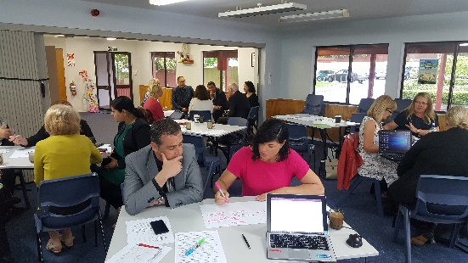
WORKING TOGETHER FOR ALL OUR CHILDREN

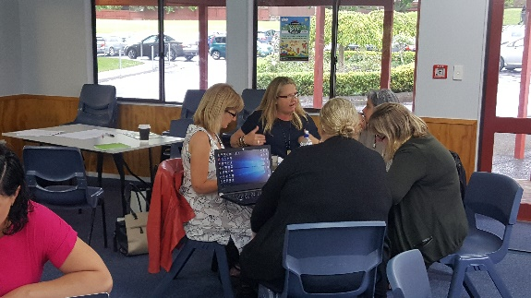
Waiho I te toipoto Kaua I te toirua
Let us keep close together, not far apart
Annual report 2017
Investing in Educational Success (IES) is a Government initiative announced in January 2014.
The main objectives were to to raise the learning (ako) and achievement of all our children and young people, particularly for students that are at most risk of underachieving.
IES plans to do this by
• encouraging greater collaboration between schools across the schooling system
• recognising, supporting and using professional expertise across the system where it is needed most
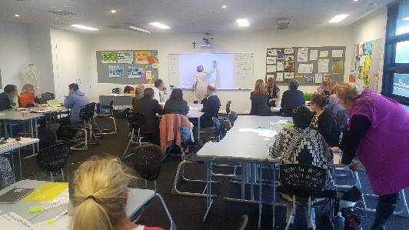
• enhancing opportunities for teacher-led innovation of new and good practice, to make clearly

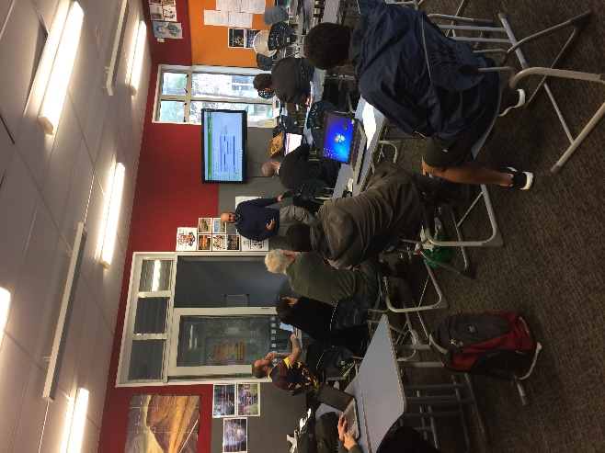
visible what is possible, new and exciting.

To support these plans Community of Schools was launched which morphed into Community of Learning and which is know known as Kahui Ako
This year has proven to be a year of ‘unknowns’ It has been ‘building the plane as it has been flying’ and at times felt like it was getting really close to the ground!
Below are snapshots of what we have achieved as the Auckland Central Catholic Kahui Ako and what we will focus on into 2018.
Staffing
6 Across the School Teachers were employed that first worked with a group of schools and then this morphed into working with Professional Development streams.
These being
- Maths
- Wring Secondary
- Wring Primary
- Cultural Responsiveness
- Data collection
- Leadership

We also have 31 Within School Teacher which have been working on Theories of improvement within their schools.

These range from Maths to Writing, Tracking and Pasifika liaison work. These theories were to be directly linked to our communities Achievement Challenges based on Writing and mathematics and lifting NCEA level 2 scores. These streams f work were to be overseen by the Across school teachers and the schools individual principals.
A leadership facilitator has been working with the AST team also looking to support their leadership capabilities.

As lead principal, I have also engaged with an expert partner who works along me in my roles offering challenge and ideas to move the community forward.
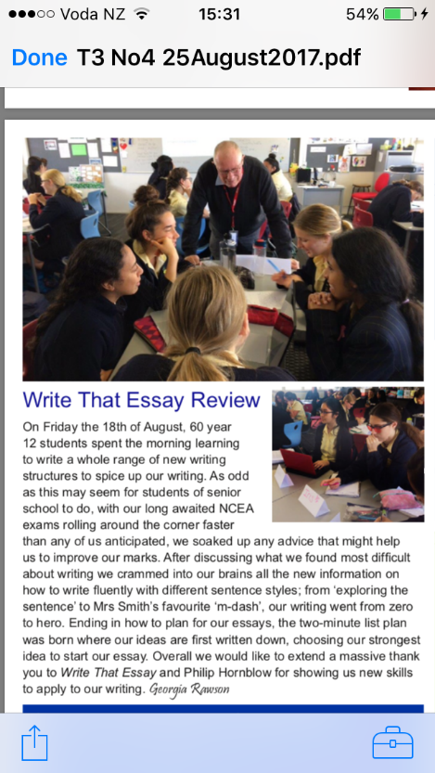
Professional Learning development
The Professional Learning development of 700 hours has been launched into schools and runs out at the end of Term 1 2018. We will again be applying for another years contracts depending on the needs of each school.

ACC Kahui Ako Strategic plan
This has been written and is proving to be a great document that is keeping the community focused on clear goals and outcomes. Based on 2 overarching goals
- Tracking and planning an educational pathway that will support each child to reach their potential
- Collaborative inquiry approaches are promoted at all levels of our Kāhui Ako
- Implementation of best practice models across our schools including culturally responsive teaching pedagogy
- Assessment practices are linked to effective teaching and learning

- Supporting excellence in learning through strong Community
- Early Childhood providers are incorporated into the ACC Kāhui Ako
- Our Māori community are connected through our ACC Kāhui Ako by a shared vision of achievement for our Māori learners
- The ACC Kāhui Ako promotes shared professional learning and strong partnerships across all schools
- Special Education needs are supported across all schools in the ACC Kāhui Ako
- ‘Bundled Services’ are used effectively and efficiently for the benefit of teaching and learning across our ACC Kāhui Ako

Thus far we have only been working on goal 1 as this is a huge piece of work.
This strategic plan is laoded on our google drive and is being up dated as we work through work streams and issues that arise. This forms part of our self-review process.

Meeting times and communication
AST Across the School Teacher meeting takes place every two weeks and collective principal meetings take place twice per term.
Information from each meeting is up loaded to a collective google drive.
AST meet with there within school teachers when needed and this has increased as PLD has started to be delivered to schools.
A newsletter is sent out to all schools at the end of each term about current progress and happenings within the ACC Kahui Ako

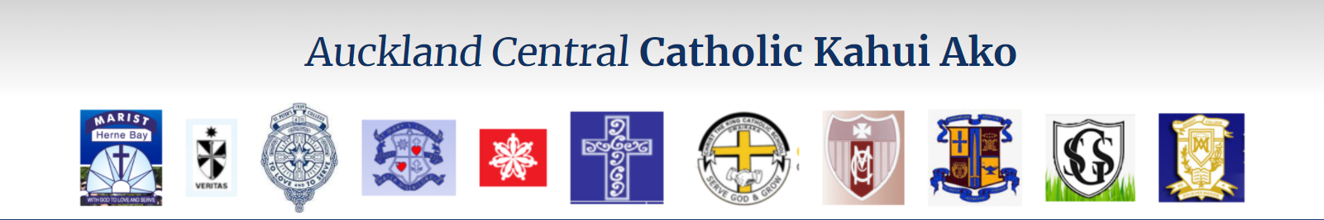

The ACC Kahui Ako website has been launched as is currently used for promotion of the community and dates. 2018 will see this being used more as an information bank and live feed question and answers platform.
Each meeting starts with prayer.

Achievement challenges
These were originally set up as part of the criteria in order for the community to be forme however it has become very obvious that these challenges need to be re written as the data that was used across our schools was not ‘clean’ and this means that what we had hoped to focus on as a group of 11 schools has changed 1 year in. We are currently collected more reliable data which will help us form more reliable achievement challenges for the 2018. From here each school will be able to break these down into their own school targets for the 2018 year.

2017 Annual review meeting
November 2017
This was held and was a great opportunity to share and re think plans for the 2018. What have we achieved, where we are going and how will we get there?

Me and my school survey
This has taken place across all schools of Year 7-10 students except one college. This college will carry out 2018.
The survey looks at learning culture in a school and can be tracked over time. It will snap shot individual schools and all Year 7-10 students across the Community.
It allows trends to highlighted and is a great place to start when looking into teacher pedagogy and student engagement.

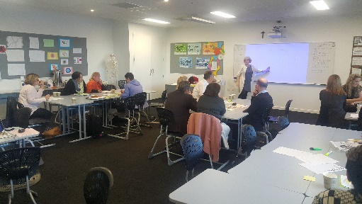

Plans going forward 2018
Re-writing the Achievement challenges using correct data gathered across the schools
Collecting real and valid data across the 11 schools based on Year 4-7 reading, writing and mathematics and NCEA results Level 2
Establishing a DP/AP/ HoD group that will support ACC Kahui Ako structure and processes within the schools which include PLD and WST theories of improvements. Wagner (2008) talks about well-meaning schools that want to make change, but without actually setting aside the time for their teachers to work together, they get little done.

Succession planning moving forward in regards Lead principal role 2018-2019

Establishing the Principal’s reference group to support my role as Lead Principal so that decisions can happen quicker and information transferred more efficiently

Engaging a Communication change manager that will fine tune the communication side of the ACC Kahui Ako which will include BOT/parent groups within each of the schools

Establishing an ACC website that is more interactive, learning based and linked to the strategic plan.

Ensuring the March 21st Conference is meaningful and purposeful for all teachers that attend.

Continue to work with WST and AST linking their appraisal evidence for ACC Kahui Ako work with their own school appraisal processes.

Continue to unpack what valid and reliable assessment data looks like across our schools and come to a common understanding about ‘achievement signposts’ now that National Standards have been removed.
Our Kahui Ako Vision

A Community of Learning│Kāhui Ako centred in Catholic faith that collectively strengthens us to develop the whole child.

Lead Principal reflection
As there is no template for this massive shift in education, it has been a year of trial and discovery. Each of our schools, for years and years, have run as separate entities and now is being asked to break down traditions and structures to ‘collaborate and ‘share’.
We now understand this takes time!
This is not a quick fix approach to sharing expertise and ideas.

Hind sight is a wonderful thing and much of what we did we would do differently again however with no instruction manual this has been part of the journey for the ACC Kahui Ako.

It has been a year of relationship and trust building. All our schools are full of great people and lead by fantastic leaders, this year has been about understanding each other and opening possible doors into each other’s schools.
Principals have had to really look at the possibilities of what ‘could be’ and not worry about their own personal gains for their schools.
Staffing has been shared and time tables disrupted to fit into other people’s plans. This has been part of the learning.
Not easy at times but we made it work as best we could in the current head spaces we were all in.

Frustration, task confusion and lack of clear direction has been some of the many emotions that the lead AST team have felt.
Many teachers within our schools are still ‘waiting’ for the Community of Learning’ to fix everything however we are slowly coming to terms with the fact that it will take all teachers, all lead teachers, all Heads of departments and all Principals and their BOT to make this happen. A Kahui Ako is by its very nature, a whole community that learns and we are coming to terms with what this means.

All of our schools are successful within their own right and therefore coming together as a community means we are coming together not for ourselves but for the collective. There is a real desire to build on the successes of each schools and drive our schools achievements as collective.

For this to happen we need to be thinking of the pathway from Year 1 to Year 13 and how we each can make a difference for every children that enters our classrooms. We know our schools are successful but are they successful for all children that enrol at them?

Sharing leadership capability and building up teacher inquiry will only make each of our schools stronger and this means better student engagement and achievement.
We have to ready our children for an ever changing world and to do this we need as many people as possible sharing and developing their own teacher practice so that we can set up our students for success.

We need to be open for ‘disruption’ and ‘change’ and believe that collectively we can deliver better for our children.

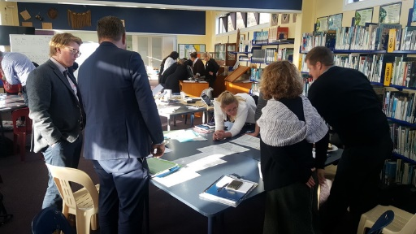The differences between primary and secondary have been another massive learning curve for myself and for those that have been involved in working with both sectors. Primary schools are smaller, their teaching style and whole curriculum understanding is different to our secondary colleagues.

Secondary are very department based and the structures and timetables within a college are less flexible. The teaching pedagogies are different and this void will need to be crossed but will take time.
Our children are leaving our primary schools and entering a very assessment based programme which for many takes time and they struggle with. Transition programmes have been touched upon this year in regards systems and assessments however we need to continue this work stream so that we set each of our primary leavers up for success in our secondary schools.

We have made huge grounds this year in regards work stream actions and getting our 11 schools off the ‘start line’. What we need to do now is to come back to the reason why we got together, our beliefs around this concept called Community of Schools.

If we are to see a true, honest partnership between our schools, we all need to have ownership of the beliefs and core understanding behind the relationship.
I see this as an overarching piece of work 2018 that will need to be done.
Otherwise, we will continue to influence small change rather than a substantial collective shift in educational thinking.

The education foundations are shifting like never before at present and we have an amazing opportunity to make it work for us and our school communities. I am so excited about the next year and what we hope to achieve as a community of learners.

Communities of Learning | Kāhui Ako: The Emergent Stage NZCER
CoL | Kāhui Ako are therefore very much still in an emergent stage, as one might expect with a major change of this nature.

It asks schools that have often been competing with each other to trust and work together, sharing their student achievement data. It also asks primary, intermediate and secondary schools to cross the boundaries between different schooling levels, and to orient themselves around student progress through the schooling years.

While many schools have taken part in Ministry-funded clusters in the past, few have taken this shape, or set clear and measurable goals.

The next few years will therefore be critical for the long-term system change that is signalled by IES. CoL will need time and well-informed support to ensure that they develop purposeful collaboration that grows member schools’ capability. The collaboration needs to be more than the sum of separate parts.
CoL membership needs to be something that is seen positively, providing understanding and joint support that adds to what each member school can do, rather than an extra workload. School leaders will need to make a commitment, however, if CoL are to have a positive impact on teaching practice.

