P A G E | 1
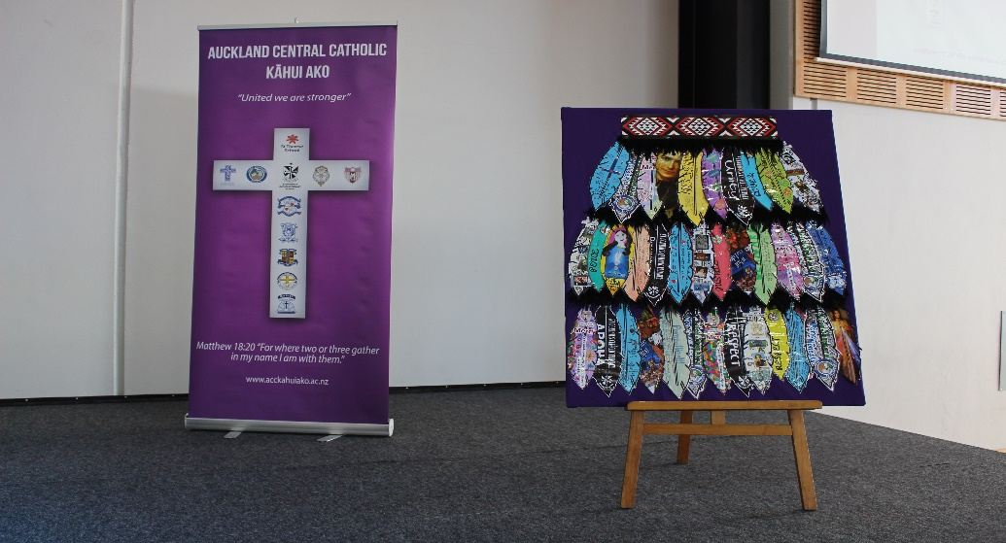
Central
Catholic Community of Learning
BOT
Information Flyer 7

WORKING TOGETHER FOR ALL OUR CHILDREN

Whakatuki
Waiho I te toipoto Kaua I te toirua
Let us keep close together, not far apart
Our Kahui Ako Vision
A Community of Learning│Kāhui Ako centred in Catholic faith that collectively strengthens us to develop the whole child.

Annual Report 2017
One year in…
Some of the key aspects that have come up over the year –

- IES - Investing in Educational Success is a total shift in thinking across our educational landscape. It is not about a small tweak here and there. It is asking us, especially with the current changing nature of education, to fundamentally rethink school structures and ways we deal with learning and teaching. We can’t just continue teaching, the way we have always taught. The job market has changed and so we must our thinking around education, if we are to create successful, positive, global citizens.

- True collaboration can only happen in high-trust environments. For many years - well basically since we started building classrooms in New Zealand - we have worked in silos. We are now in a position to see what real collaboration looks like, and to do that, we need plenty of trust. We have to de-privatise our classrooms and teaching practices. We have to be ready to learn and share openly.

- Communication is very important if schools are all going to feel part of a community. For all of us to feel part of something, we need to know where we fit in, that there is a clear direction, and that this is being shared with all that make up this community. These communication lines take time to build and secure. Relationships need to be formed, managed, and strengthened as we go forward.

- Great leadership is vital if a school is going to thrive and ignite great learners. We have to have the best leaders driving our classrooms, teams, departments and schools. Without solid, engaging and student- centered leadership, we are merely doing what we did last year, the year before and the year before that. We have to be better, we have to have the best leaders making change and driving the practice that will make the greatest impact.

- You don’t always get given a template in life. We determine the direction and the outcome we want within this Kahui Ako. A community by the very definition, is the sharing of, or having certain attitudes and interests in common.

Ours is centred in the Catholic faith that collectively strengthens us to develop the whole child. Together we are creating the template we all want.
As a community we need to collectively think of smarter ways, share more effective practices, and create urgency for the 4,700 students that deserve our best, every day.

- We have made some small steps forward, but also many back, as we come to learn and understand each other’s places of teaching.

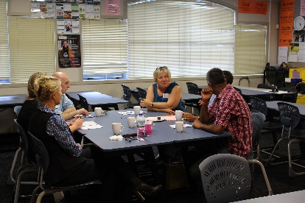
Primary and secondary are, at times, like crossing the grand canyon in teaching practices and understandings of the learner, however this is what our Kahui Ako is all about, and it will take time for each of us to unpack this.

Staffing
In Term 1 2018 we had five Across School Teachers, one of whom has been released to take up a Deputy Principal role at St Mary’s College. Four of the six Across School Teacher roles come up for review at the end of 2018. We will be advertising at the end of Term 3 2018 for these roles.
The Lead Principal role comes up for review at the end of Term 3 2018. We are currently looking at options for this role. The Process as follows:-
- Current principals of the community are asked to apply.
- If no applications are received, or if a principal applies and is unsuccessful, then the offer goes out to the senior leaders inside the 11 schools.
- If still applications are received, or if the applicants are not suitable, then the Kahui Ako goes into negotiations with MOE for a shared leadership model.

Across School Teacher Roles
As a Kahui Ako we applied for professional delivery hours, but were unsuccessful on the hours we asked for. We have been granted 200 hours, which means 4 of the 5 focuses for the schools now have to be reassigned.

Focuses to move forward with will be:-
- Assessment data and tracking targeted children.
- Cultural responsive teacher practices.
- Curriculum levels and what this means for our schools.

Achievement Challenges
These have changed now that we have ‘cleaned’ up the original data. They are as follows:-

Target 1—Year 4 - 7 Writing
There are 1,087 Year 4 to Year 7 students in our Community of Learning (end of 2017). Currently we are at 85.5% ‘at/above’ in writing (boys and girls) or 911 students. We need to collectively shift 69 students.

Of these students…
51/64 are Māori ‘at or above’ (80%) and 179/244 (73%) Pasifika ‘at or above’.
100/152 Māori and Pasifika Boys are ‘at or above’ (65.7%).

We aim to…
We aim to shift our Māori and Pasifika boys to 90%, which means we need to move 37 Māori and Pasifika boys across our schools. So of the 69 students we need to shift, 37 need to be Māori and Pacifica boys.

Target 2—Year 4 - 7 Mathematics
There are 1,070 Year 4 to Year 7 students in our Community of Learning (end of 2017). Currently we are at 85 % ‘at/above’ in mathematics (boys and girls) or 904 students. We need to collectively shift 59 students.

Of these students…
51/63 are Māori (81%) ‘at or above’ and 181/254 (71.3%) Pasifika ‘at or above’. 113/157 Maori and Pasifika boys ‘at or above’ (72%).

We aim to…
We aim to shift our Maori and Pacifica boys to 90%, which means we need to move 29 Māori and Pasifika boys across our schools. So of the 59 students we need to shift, 29 need to be Māori and Pacifica boys.

Middle leadership
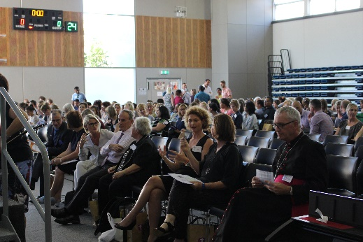
All middle leadership (which include Deputy Principals, Associate Principals and Heads of Departments) are now invited to all Principal Meetings. This is to support the momentum of the Kahui Ako, and allow for information to better flow between levels within a school.

ACC Kahui Ako Website
This is coming together well, and is becoming a place where information is shared and progress is updated for all to see.

The engagement of a Communication Change Manager has taken place. This means they will be able to support the community as we track into its second phase, 2018 – 2020.

ACC Kahui Ako Kotahi Conference
This was held on the 21st of March at Marist College. There were 52 workshops that were put together, which I think is a huge celebration for our Kahui Ako! TEACHERS teaching teachers!

Plans going forward for 2018
- Transitioning the new Lead Principal, including establishing the Principal Steering Group, and preparing the transition for the first tranche of Across Kahui Ako Teacher appointments.
- PLD veins continue to be delivered throughout 2018 to ensure a level playing field across all 12 schools, as work streams by current Across School Teachers develop a culture of schools supporting schools.
- Development of a Communications Report and then Implementation Plan through the use of a Change Manager
- Collectively decide how we plan to track students, now that National Standards are out of mix. This is only one aspect of the new approach to the use of Across School Teachers - developing assessment capable learners, and as a result, developing a common language of effective teaching and learning across the Kahui Ako, based on clearly articulated assessment processes, systems and language.
