P A G E | 1

Central
Catholic Community of Learning
BOT
Information Flyer 5
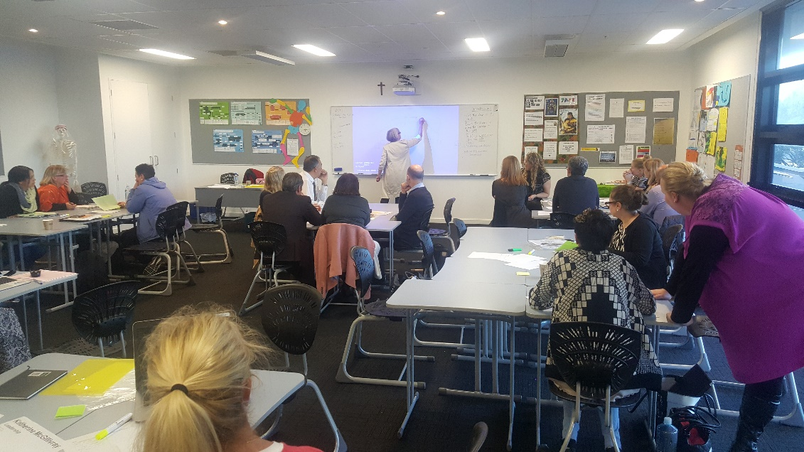

WORKING TOGETHER FOR ALL OUR CHILDREN

Waiho I te toipoto Kaua I te toirua
Let us keep close together, not far apart
Term 3 2017
Schools in the Community
- St Mary's College (Ponsonby)
- St Paul's College (Ponsonby)
- St Peter's College (Epsom)
- Marist College
- Christ the King Catholic School (Owairaka)
- Good Shepherd School
(Balmoral)
- Marist School (Mt Albert)
- Marist School (Herne Bay)
- Monte Cecilia Catholic
School (Mt Roskill)
- St Dominic’s Catholic Primary School (Blockhouse Bay)
- St Therese School (Three Kings)

What are the up-dates?

- Professional Learning development
This term has all been about lifting the Professional Learning Development (PLD) 700 hours into the schools.
In term 2 schools were asked to choose what PLD they were seeking for their schools. From this information Across the Schools teachers were allocated to each of the work streams.
Originally we only had 5 work streams but through the term it became obvious that we needed a Data scope of work to ensure that all schools were dealing with true and accurate data when looking at student achievement and shifts across the 11 schools.
The 6 work streams are
- Leadership
- Mathematics
- Year 0-8 writing
- Year 9-13 writing
- Data
- Cultural responsiveness
Each Across the School teacher is responsible for engaging with PLD providers and ensuring that the PLD being offered to school is needs based and focused. They are also working in joining schools together in regards their needs to share practice and ideas.

- ACC Kahui Ako Strategic Plan
The ACC Kahui Ako Strategic Plan has been completed and is currently with principals to be presented to each of the Board of Trustees at some point Term 3 and 4.
The two overarching goals of the strategic plan are -
Strategic Goal 1: Educational Pathway
Tracking and planning an educational pathway that will support each child to reach their potential
Strategic Goal 2: Supporting excellence in learning through strong Community
Strengthening the ties and relationships between our schools, our children and families, to support student engagement and excellence in learning
- Collective Mini Conference planned
21 March 2018 from 2:00pm – 6:00pm at Marist Primary and Marist College
This is currently being planned with the following timetable for the session as follows
2pm Whole Kahui Ako liturgy with Bishop Patrick
2:30 Key note speaker
3:30 afternoon tea
4pm Break out workshops
6pm Wine and cheese
- Meetings held this term
Transition Year 6/7
This term we held the first session around the transition of our Year 6 into the Year 7 year. This has always been an issues for primary schools in regards understanding what the colleges are looking for in there year 7 students and was there any way we could support the process by getting them better prepared for the transition.
We has all primary and colleges represented and it was an excellent first attempt to clearing up this area of the ACC Kahui Ako.
Topic that were discussed were as follows
- Assessment tools
- Enrolment data
- Enrolment forms
- Timings of open days
- Self- management aspects to starting colleges.
All Across Schools Teachers AST and Within School Teachers WST meet this term at St Mary’s college. This meeting was facilitated byTteam Solutions and is one of many being planned for this collective group to build up our common language of understanding around leadership.
Courageous Conversation with Glen Singleton
This was held at Vermont Street Columbia Centre and was open to all leadership across the 11 schools International speaker about RACE. It calls for open discussions about RACE and what this loks like personally and within communities.
Across the School teachers meeting with their schools and PLD providers in setting up the contracts across the 11 schools
Within the School teacher running staff meetings and group based sessions within the Individual schools they work within.

- Plans going forward
Term 4 2017 - PLD engagement across the community based on Achievement Challenges
Re-writing the Achievement challenges using correct data gathered across the schools
Principals meeting on the 8th November to review the 1 year anniversary and to look at possible direction for 2018 and beyond using the Strategic plan as the guiding document
Collecting real and valid data across the 11 schools based on Year 4-7 reading, writing and mathematics and NCEA results Level 2
We continue to learn and grow as a community of schools.
1 year in and there are many new challenges and opportunities presenting to us. As a group a schools we committed to working through the barriers and unpacking the opportunities to ensure we are taking full advantage of this new way of learning together.

A Community of Learning│Kāhui Ako centred in Catholic faith that collectively strengthens us to develop the whole child.

