P A G E | 1
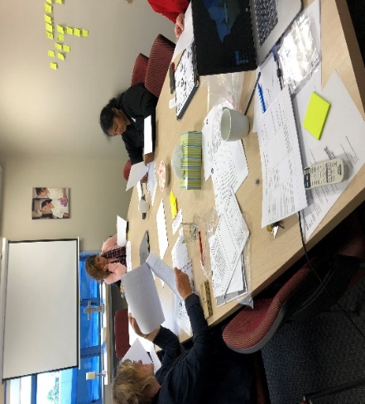
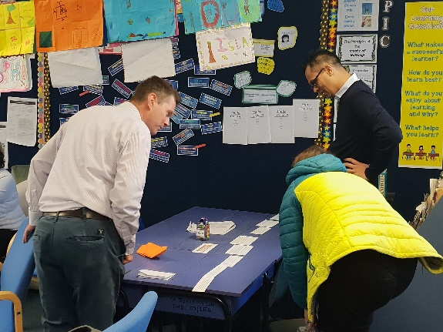
Auckland Central Catholic
Kahui Ako

BOT Flyer 8

WORKING TOGETHER FOR ALL OUR CHILDREN

Whakatuki
Waiho I te toipoto Kaua I te toirua
Let us keep close together, not far apart
Our Kahui Ako Vision
A Community of Learning│Kāhui Ako centred in Catholic faith that collectively strengthens us to develop the whole child.

Lead Principal Role
At the end of Term 3 2018, the Lead Principalship will change. Daniel Pepper has completed his two year contract with the community and we are currently going through the appointment process to replace Daniel.

Across School Teachers Running Workshops Across the Schools
The six Across School Teachers are currently running workshops across our 12 schools, and all teaching staff are invited to attend. Two afternoon workshops have been marked on school calendars, so that all teachers are given the opportunity to participate in this professional development.

Topics include:-
- What are our secondary schools’ expectations of students, as they enter schools at Year 7?
- Culturally Responsive Practice: Is it more than just relationships?
- Systems for tracking student achievement within a primary school environment.
- Strengthening Teacher Capability with Formative Practice (Part 1).

- Teaching Investigating Skills in Year 7 and 8 Science

Our Communication Plan, Moving Forward
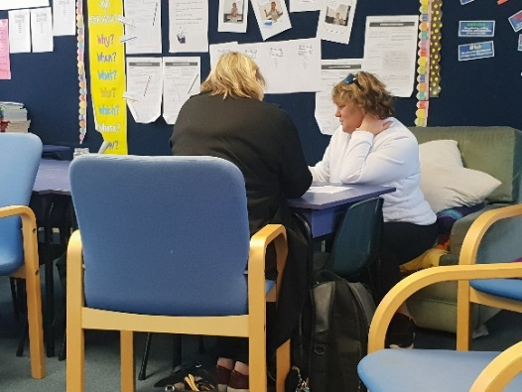
We currently have a Change Manager contracted to the ACC Kahui Ako who is working with the schools around a communication piece. The following actions have been created so that we move forward into the next two years, stronger and tighter than ever.

Megan Tomkies has set out a very clear and easy to follow ‘action plan’ that she hopes will support schools and their Boards of Trustees with commitment, and links between the schools.

These aspects will further develop and grow the community, and bind us closer together so that we can achieve the goals as set out in the ACC Kahui Ako Strategic Plan.

- Confirming commitment to the Kāhui Ako vision and purpose.
- Schools will have considered how the Kāhui Ako Strategic Plan is contextualised within their school and communicated it to their teachers (elevator speech).
- Preparing for the next phase of the Kāhui Ako’s journey:
- The job descriptions will be written for the Across School Teacher roles.
- The job descriptions for the Within School Teacher roles will be reviewed and changed as required.
- ‘Collective Norms’ - a Team Charter is established.
- Creating a cycle of communication for audiences –

(timely, purposeful, simple, clear, concise)
- Regular tracking of progress of work, communication of next steps and review points. This will build our brand.

‘Write that Essay’ Toolkit for Writing
An excellent piece of work has come out of the professional development, based around writing across the schools. This tool gives guidelines for what is expected of our children (years 2 – 10) to have what is needed in order to write a successful essay at years 10 - 13.

For primary school and secondary schools to know what is expected from each other, allows us to better prepare our children.

PAT Maths Data being taken for 2019 Data
At the end of Term 3 – Term 4, all year 4 - 7 children from across our 12 schools will sit a Maths PAT test.

This will allow us to set goals using the data, for the 2019 year. It will help us to show shift in our children’s achievement.
Student Voice being captured for Work Stream

Student Voice is currently being captured across our 12 schools, as part of the work piece looking into ‘cultural capital’ and children understanding their place at our schools.

Professional Development Application Unsuccessful

We have been unsuccessful in the last two rounds of applications for PLD resourcing. Processes and application information is currently being looked at to ensure that we are getting what is required when making an application.

Across School Teachers and Within School Teachers

These roles are coming up for renewal.

Across School Teacher roles are appointed through the Appointment Committee, set up from the Across School Teachers. Within School Teacher roles are appointed through each individual principal, as part of their school staffing structure.

National Trends that our own ACC Kahui Ako is finding

- More support is needed to understand and develop student data across the schools.
- There is little school community understanding around Kahui Ako’s
- Board of Trustees’ current lack of involvement with Kahui Ako’s
- Great practice is being shared, using the Across School Teachers.
- The need for leadership development across the community.
- A real sense of possibility is being felt across the schools of “what could be…”

ACC Kahui Ako Conference
25th March 2020
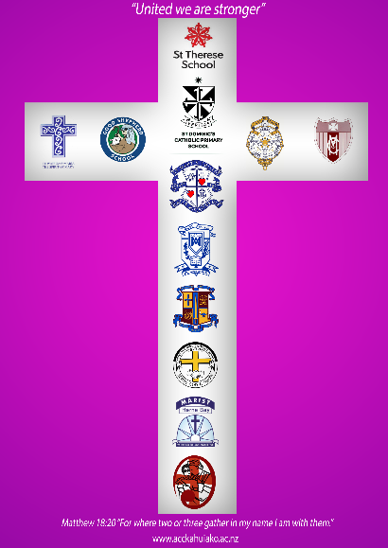

Stage 2 of the ACC Kahui Strategic Plan 2018-2019

Over the coming months we will start to unpack Strategic Goal 2 of the ACC Kahui Strategic Plan.

Strategic Goal 2: Supporting Excellence in Learning through Strong Community
Here we start to unpack the wider community and the impact the Kahui Ako could have there.

Following are the elements that are currently in Goal 2 of the Strategic plan.

- Early Childhood providers are incorporated into the ACC Kāhui Ako.
- Our Māori community are connected through our ACC Kāhui Ako, by a shared vision of achievement for our Māori learners.
- The ACC Kāhui Ako promotes shared professional learning and strong partnerships across all schools, which includes a Conference in 2020.
- Special Education/ESOL needs are supported across all schools in the ACC Kāhui Ako.

St Joseph’s Grey Lynn
We officially welcomed St Joseph’s Grey Lynn to the community this term. The ACC Kahui Ako is now made up of 12 schools - 8 primary schools and 4 secondary.

Current Statistics as at 25/6/2018

Total number of children 4,767
Total primary 1-8 2,334
Total secondary 2,433
Total Maori 400
Total Pasifika 1,141
Total Asian 796
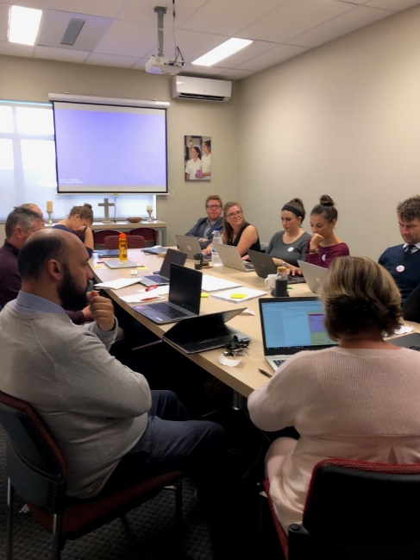
Total Teachers 327

